**Preparing for your Connect For Education Course**

**Purchasing Your Access Code**

In order to access the course materials, you will need to purchase and Access Code. You may purchase your Access Code from the campus bookstore or you may purchase your Access Code directly from Connect For Education’s online store (<http://mywebtext.com/shop-2>). Please note: if you are using financial aid, you may need to purchase the access code from the campus bookstore.

Provided below are instructions to purchase the Access Code from the C4E online store:

1. Access the Connect For Education Online Store (<http://mywebtext.com/shop-2>).
2. Select the course you are taking by using the search field or by selecting one of the product category links.  
     
   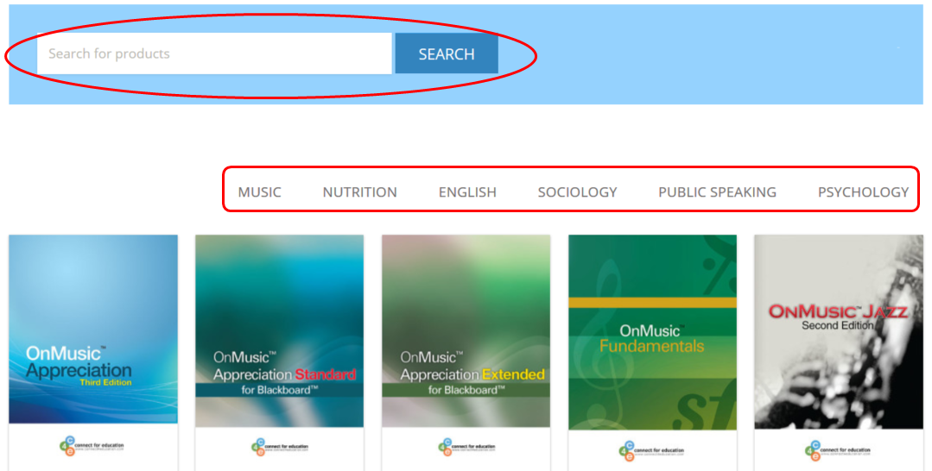
3. Click the ‘**Add to Cart**’ button to add the Access Code to your cart.
4. The **Terms & Conditions** of the purchase will be displayed. Please be sure to read and understand the **Terms & Conditions** of the purchase.

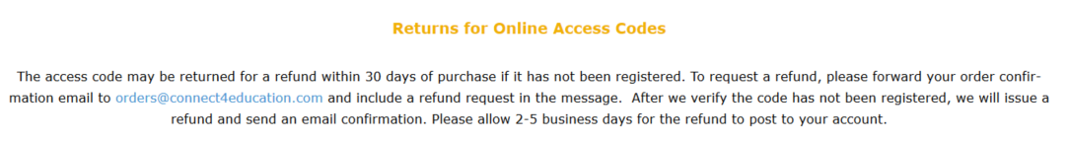

1. Click the ‘**Proceed to Checkout**’ button to enter your Shipping and Billing Information.   
     
   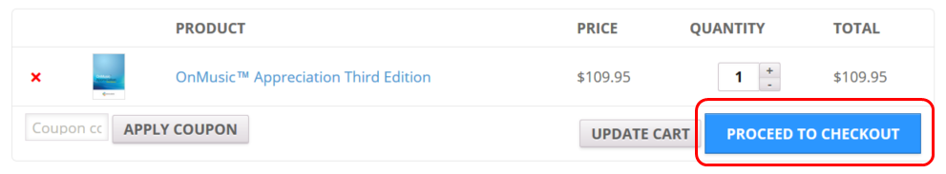
2. Once you have read and understood the **Terms & Conditions**, you will need to check the box to indicate that you accept the **Terms & Conditions** of your purchase.



1. Once you complete the purchase process, your 14-digit Access Code will appear on the Confirmation screen after your payment has been confirmed. It will also be emailed to the email address provided during the purchase process. If you do not see the email, be sure to check your Spam / Junk Mail folders.

**Note**: If you are unable to find the Access Code in your Inbox, please check your email’s spam/junk mail folders. You can also request the Access Code to be re-sent to you by contacting [orders@connect4education.com](mailto:orders@connect4education.com) or by calling (703) 880-1180 x111.

**Registering Your Access Code**

Once you have purchased your 14-digit Access Code, you will need to register it on the Connect For Education Student Registration Page (<http://register.mywebtext.org/>).

1. Access the Student Registration Page at <http://register.mywebtext.org/>.
2. Select your **School** first, followed by the **Instructor**, **Semester**, and **Course**. The fields below will auto-populate with the available selections. Please double your selections to ensure you are registered for the correct course.
3. Enter the Access Code you purchased in the ‘Access Code’ field.
4. Select a Login Name and Password for your account.

**NOTE:** Login names and passwords are case sensitive.

1. Enter your First Name, Last Name, Email Address, and Phone Number in the respective fields.
2. Once you have read the Terms & Conditions of the Registration, check the box to agree to the terms.
3. Click the ‘Submit Registration’ button to complete your registration. A confirmation email will be sent to you to confirm your registration.

Note: All fields on this form are required!

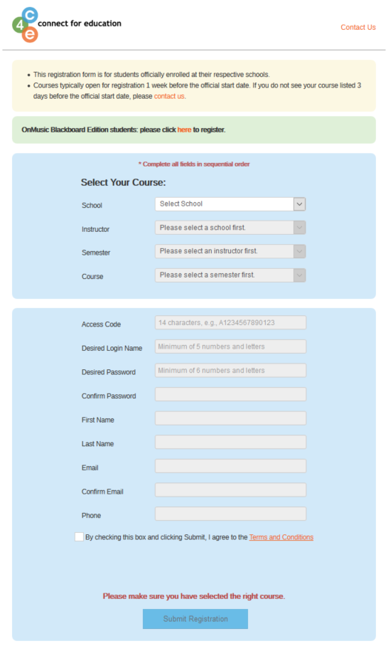

**Accessing Your Course**

Once you have successfully registered you Access Code on the Student Registration page, you can immediately proceed to the Connect For Education Course Site ([www.c4edu.org](http://www.c4edu.org)) to begin your course work. You will log into the Connect For Education Course Site using the Login Name and Password created during the Registration process.

Note: If you are unsure of your password, simply click the ‘Don’t know your password?’ link. An email will be sent to the email associated with your account allowing you to reset your password.

**Technical Questions or Issues**

In the event you have any questions or issue(s) related to the course and require additional assistance, please contact Connect For Education Technical Support for assistance:

**Email**: [support@connect4education.com](mailto:support@connect4education.com)

**Phone**: 703-880-1180 x200

**Hours**: Monday - Friday, 9 a.m. ET to 6 p.m. ET