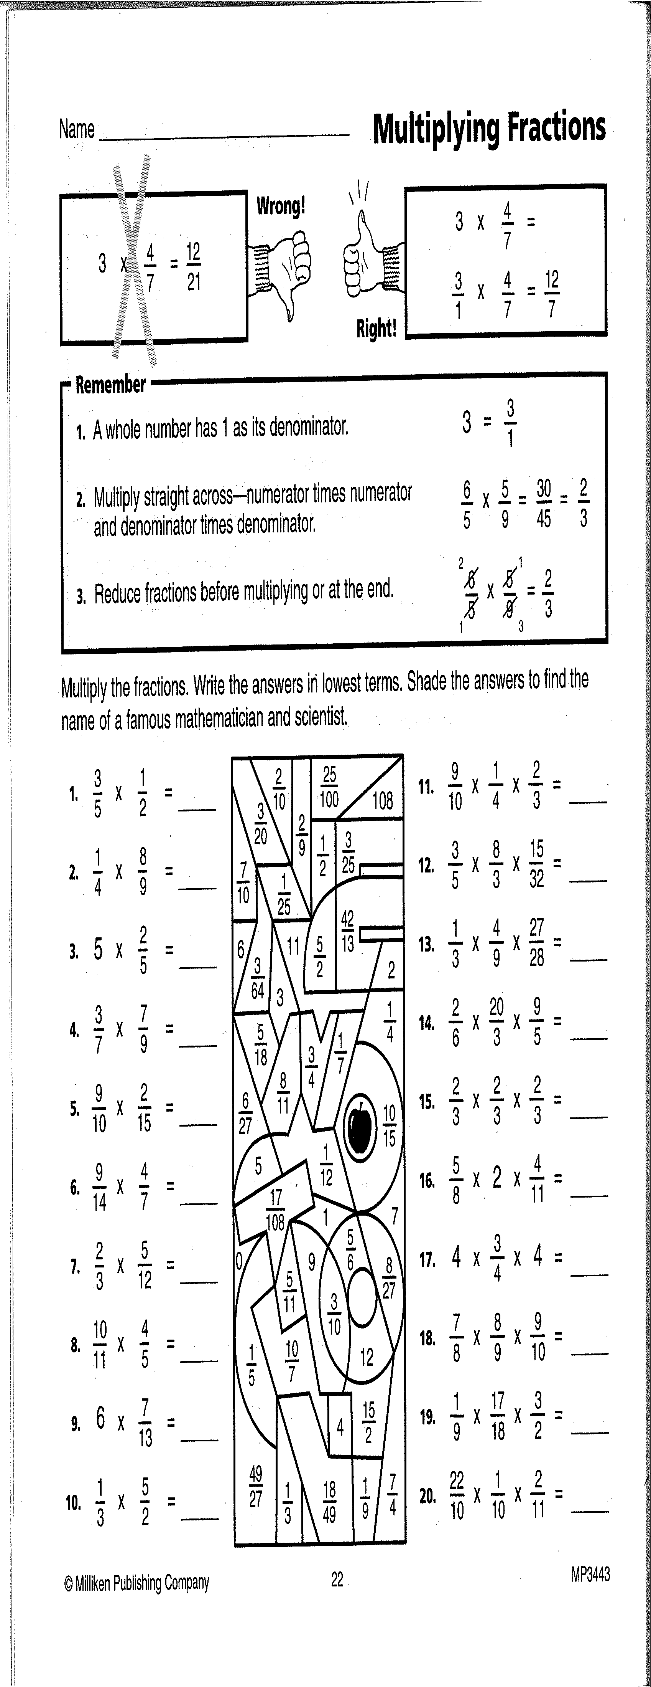
Activity 2: Multiplying Fractions (Fill-in all the blanks!)
(Shade-in the appropriate regions!)

