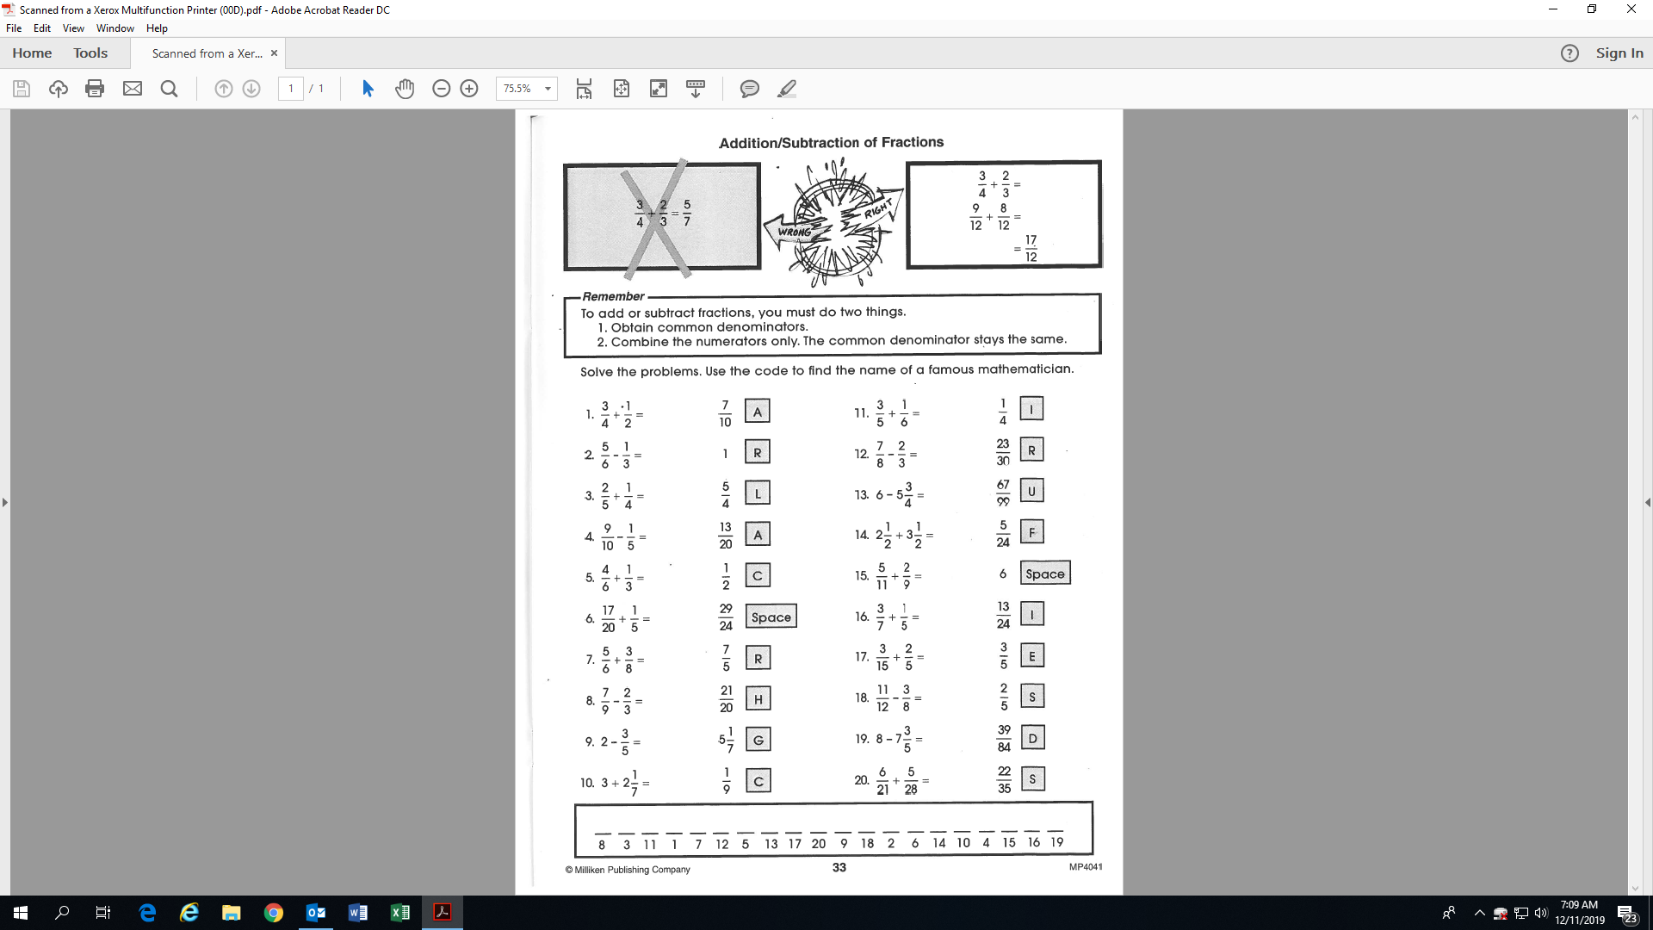

**Activity 5: (Fill-in all the blanks!)**



L