**Name:__________________________________**

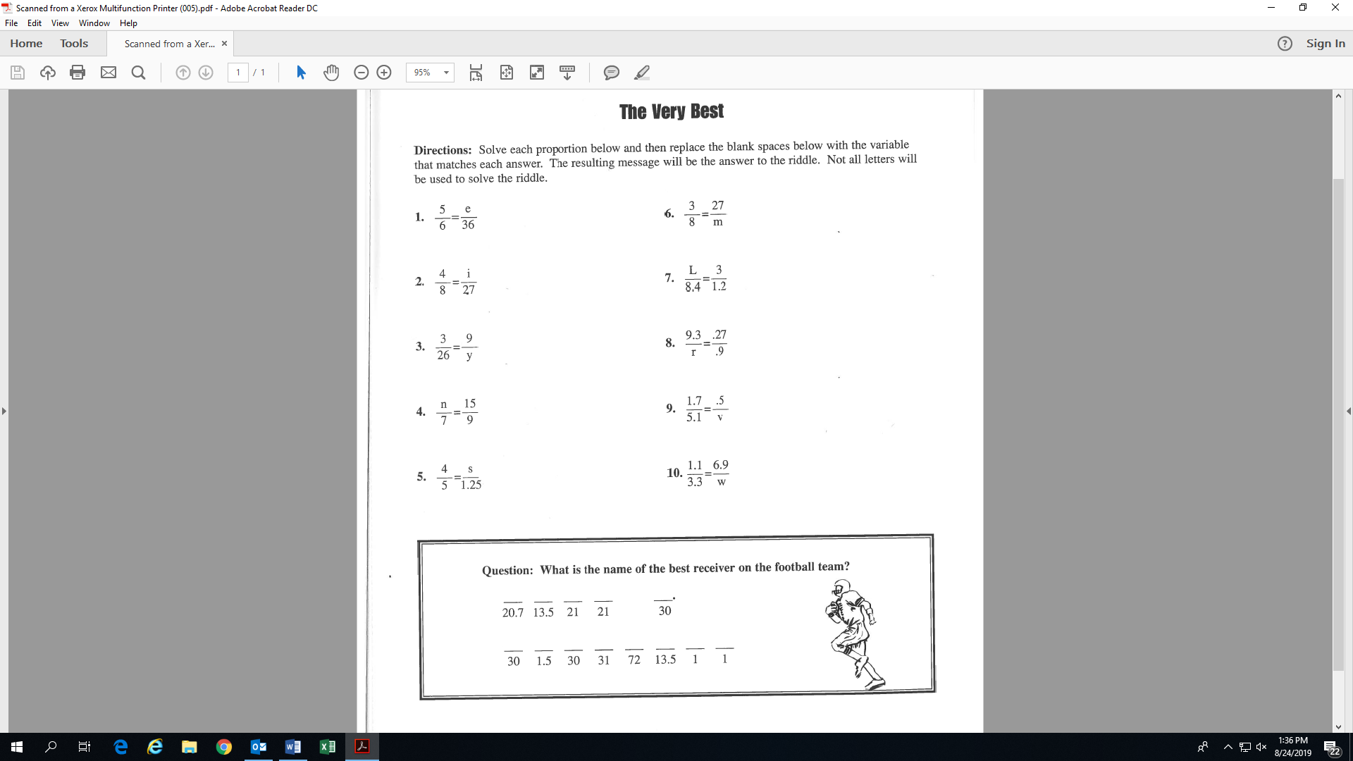

e.

(m =

(v =

(r =

**Activity 10: (Fill-in all the blanks and solutions!)**

(e = 30)

(i =

(y =

(n =

(s =

(w =

(L =