**Name:________________________________**

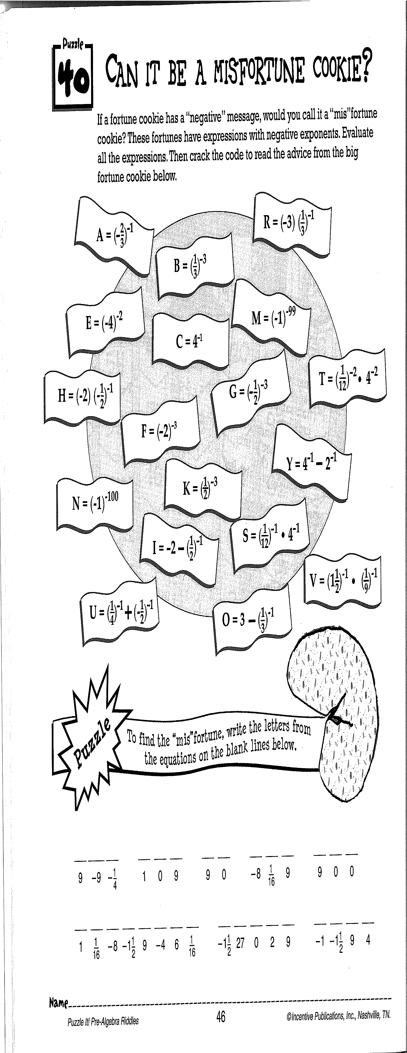

(S =

(F =

(C =

(U =

(B =

(R =

**Activity 11:**

**(Fill-in all the blanks and solutions!)**

(A = -1 ½)

(M =

(E =

(T =

(H =

(N =

(I =

A

A

A

(G =

(Y =

(K =

(V =

(O =