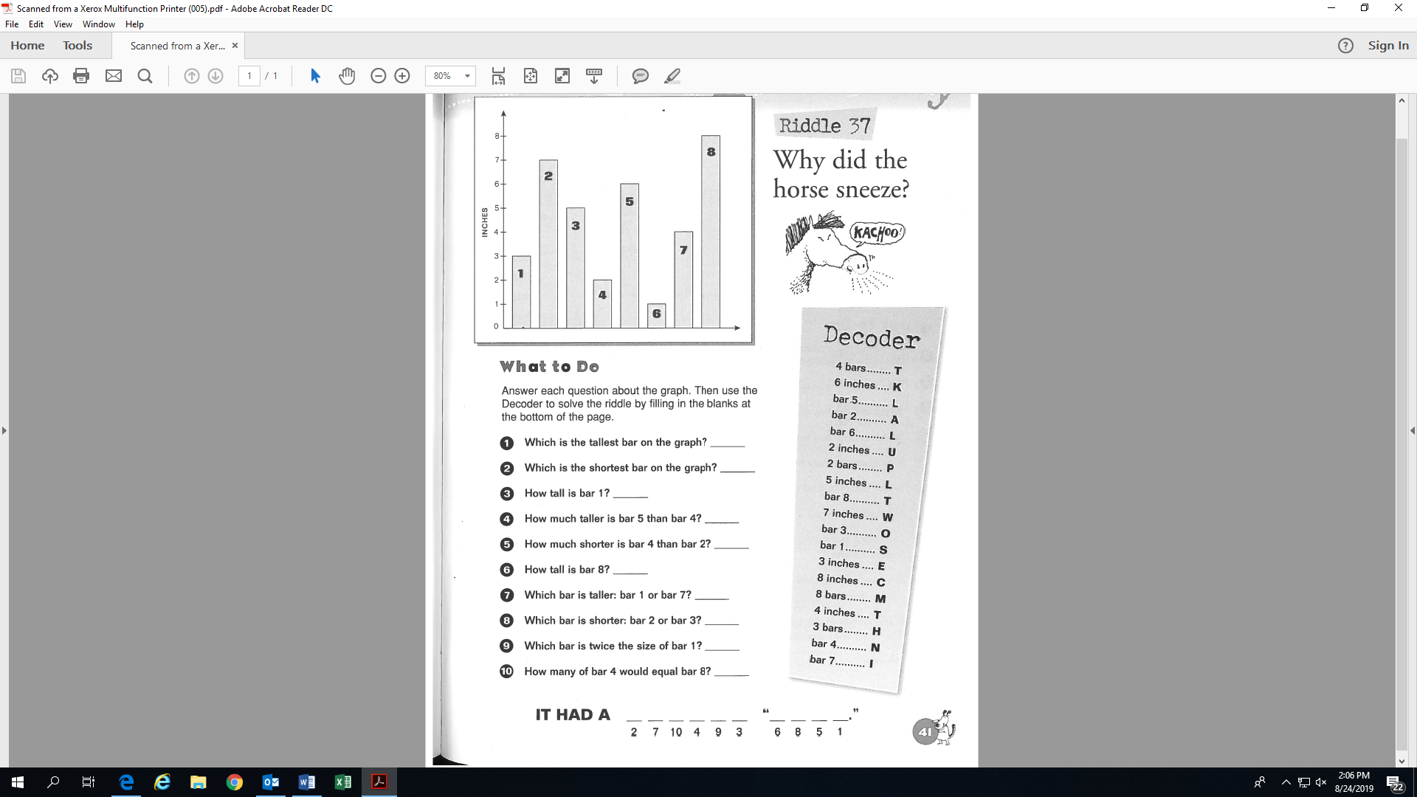

**Activity 12:**

**(Fill-in all the blanks!)**

**Name:_______________________________**

bar 8

T