**Name:________________________________**

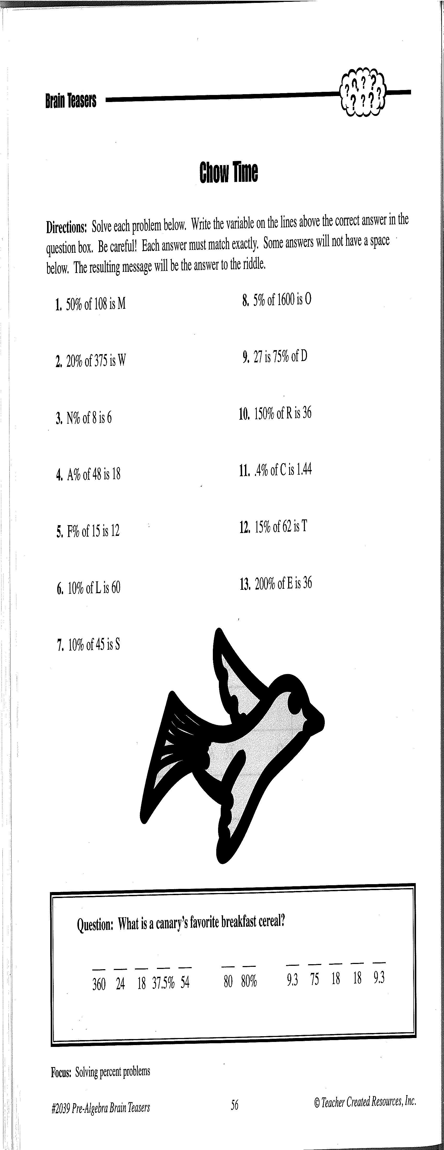

(C =

(E =

M

A

(L =

(F =

(A = 37.5%)

(N =

(W =

(M = 54)

(O =

**Activity 13: (Fill-in all the blanks and solutions!)**

(D =

(T =

(R =

(S =