**Name:_________________________________**

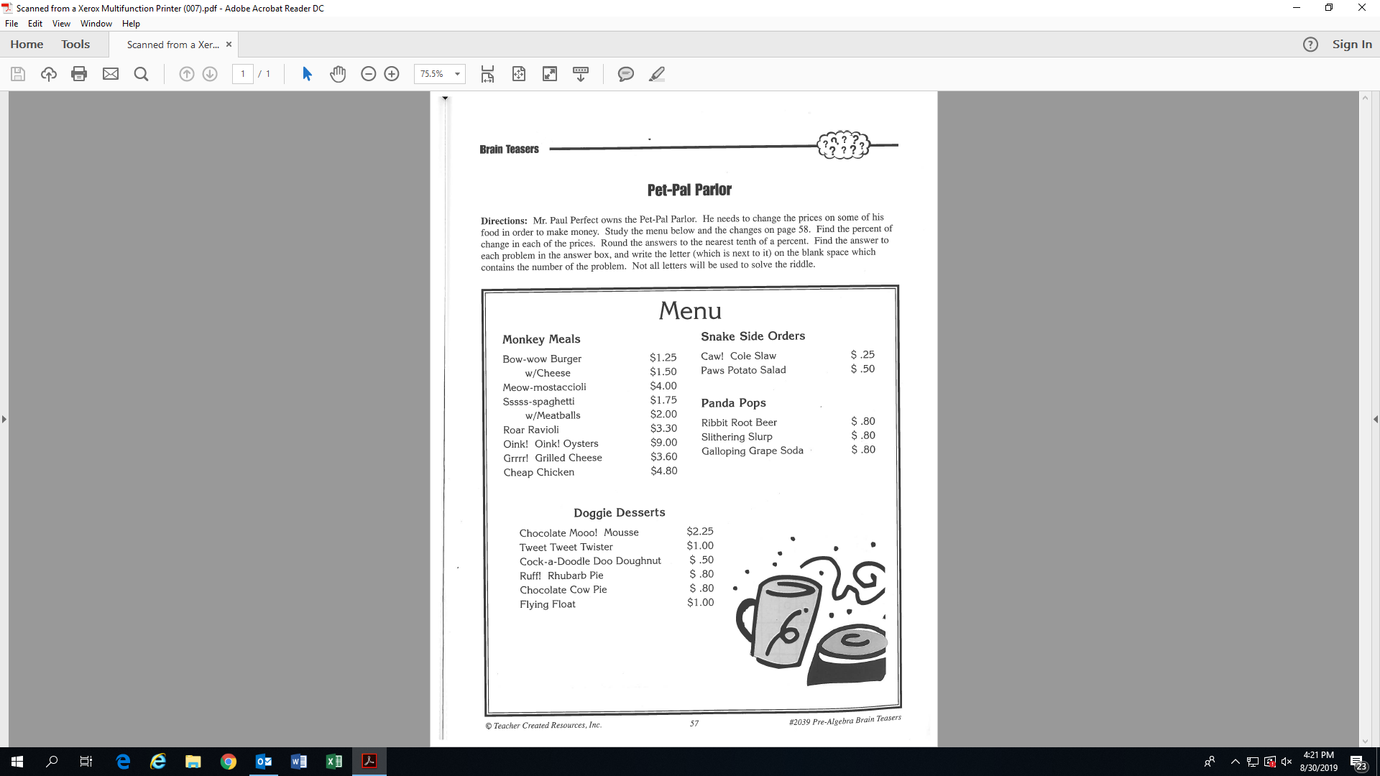

**Activity 14: (Fill-in all the blanks and solutions!)**

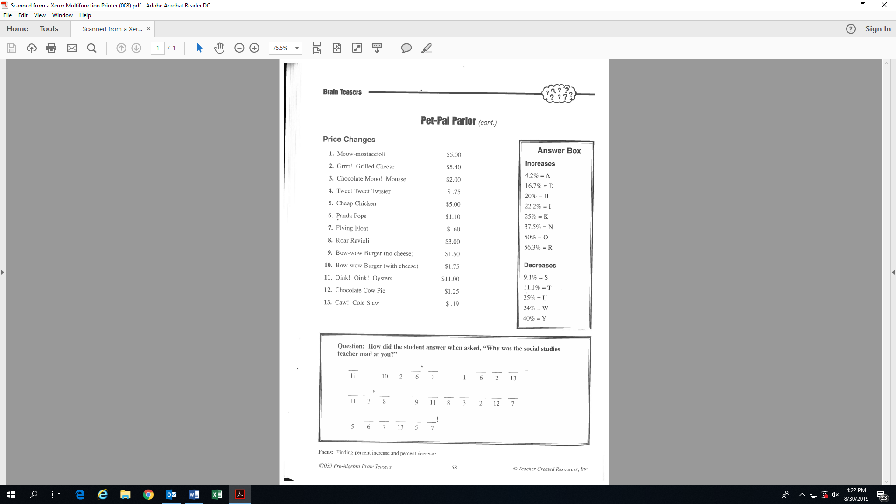

($1/$4 = 25%)

(-$.25/$2.25 = -11.1%)

K

’

T

T

T‘