**Name:________________________________**

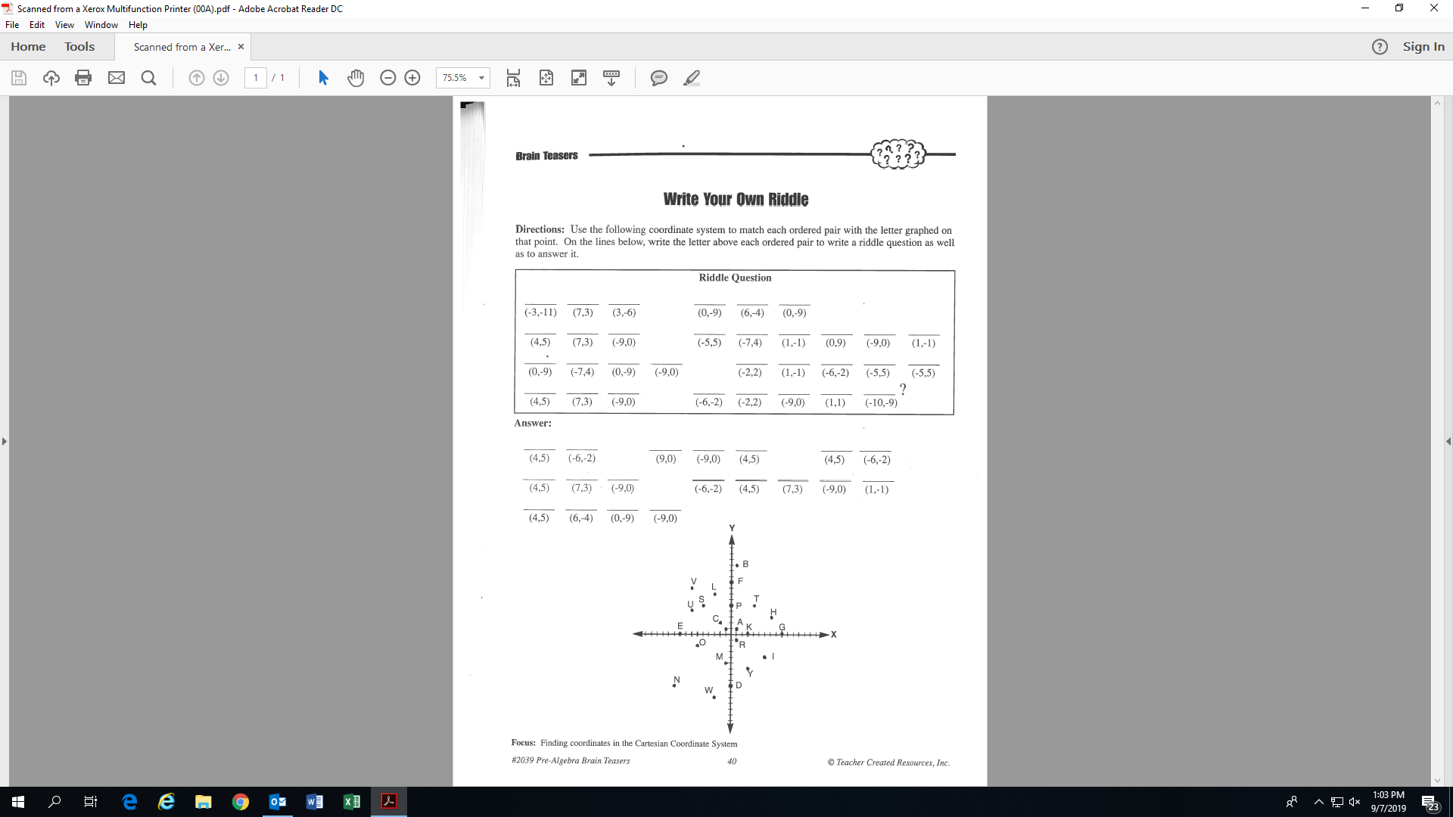

W

**Activity 15: (Fill-in all the blanks!)**