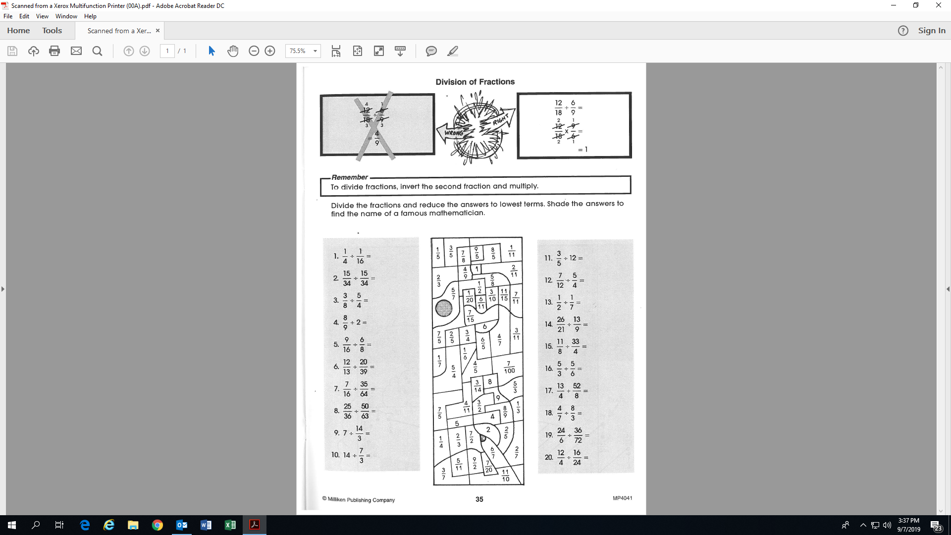**Name:_______________________________**

**Activity 16: (Fill-in all the blanks!)**

**(Shade-in the appropriate regions!)**

4

1