**Name:_______________________________**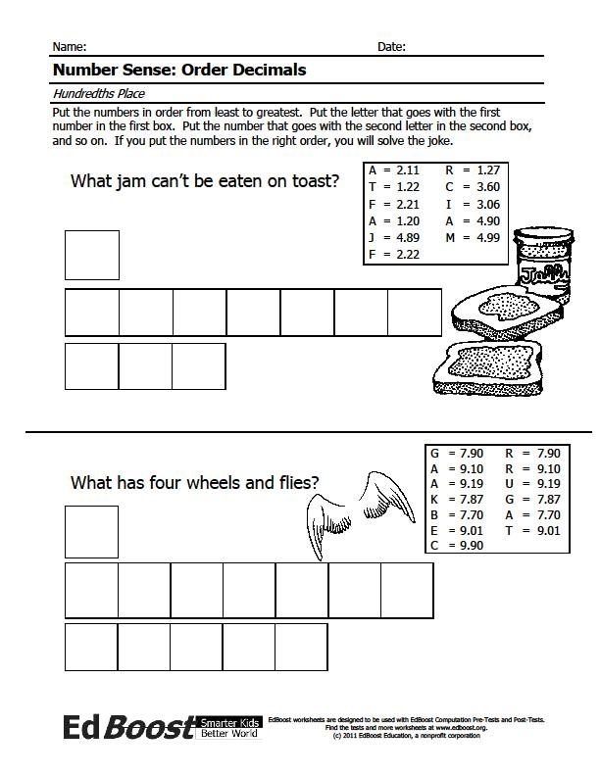

**Put the numbers in order from smallest to largest. Put the letter that goes with the first number in the first box. Put the letter that goes with the second number in the second box, and so on. If you put the numbers and corresponding letters in the right order, you will solve the riddle.**

**Activity 17:**

**(Fill-in all the blanks!)**

|  |  |
| --- | --- |
|  |  |
|  |  |
|  |  |
|  |  |
|  |  |
|  |  |
|  |  |