**Name:________________________________**

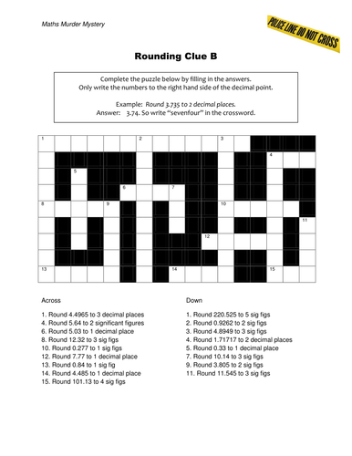

**Across Down**

**1. Round 4.4965 to the thousandths 1. Round 220.525 to the hundredths**

**4. Round 5.64 to the tenths 2. Round .9262 to the hundredths**

**6. Round 5.03 to the tenths 3. Round 4.8949 to the hundredths**

**8. Round 12.32 to the tenths 4. Round 1.71717 to the hundredths**

**10. Round .277 to the tenths 5. Round .33 to the tenths**

**12. Round 7.77 to the ones 7. Round 10.14 to the tenths**

**13. Round .84 to the tenths 9. Round 3.805 to the tenths**

**14. Round 4.485 to the tenths 11. Round 11.545 to the tenths**

**15. Round 101.13 to the tenths**

**9**

E

**Activity 18: Complete the puzzle by filling in the answers. Only write the numbers to the right side of the decimal point as letters.**

**For example: Round 3.735 to the hundredths place. The answer is 3.74, so write the letters *SEVENFOUR* in the crossword.**

**3**

N

**2**

F

**1**

N

E

S

V

E

I

N

R

U

O

**4**

**5**

**7**

**6**

**10**

**8**

**11**

**12**

**15**

**14**

**13**