**Name:_______________________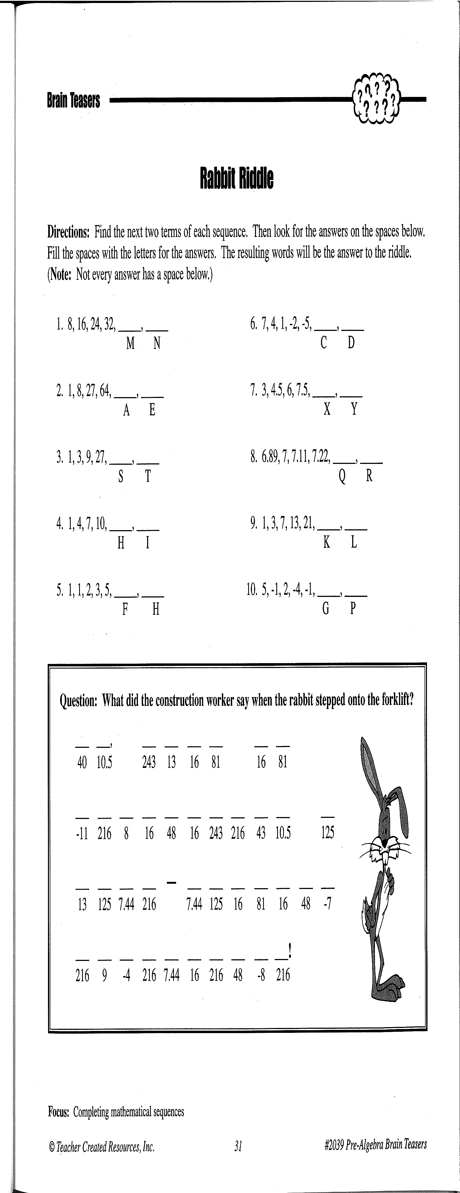______**

**Activity 1: (Fill-in all the blanks!)**

40

48

N

N

N

M