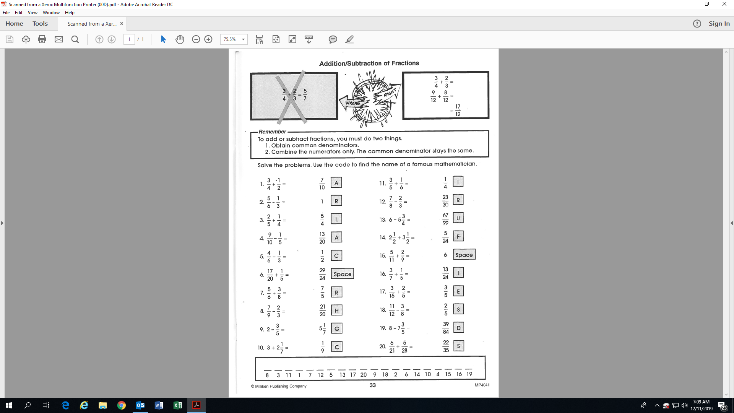

**Name:__________________________________**

**Activity 20: (Fill-in all the blanks!)**

L

5/4 = L

=