**Name:__________________________________**

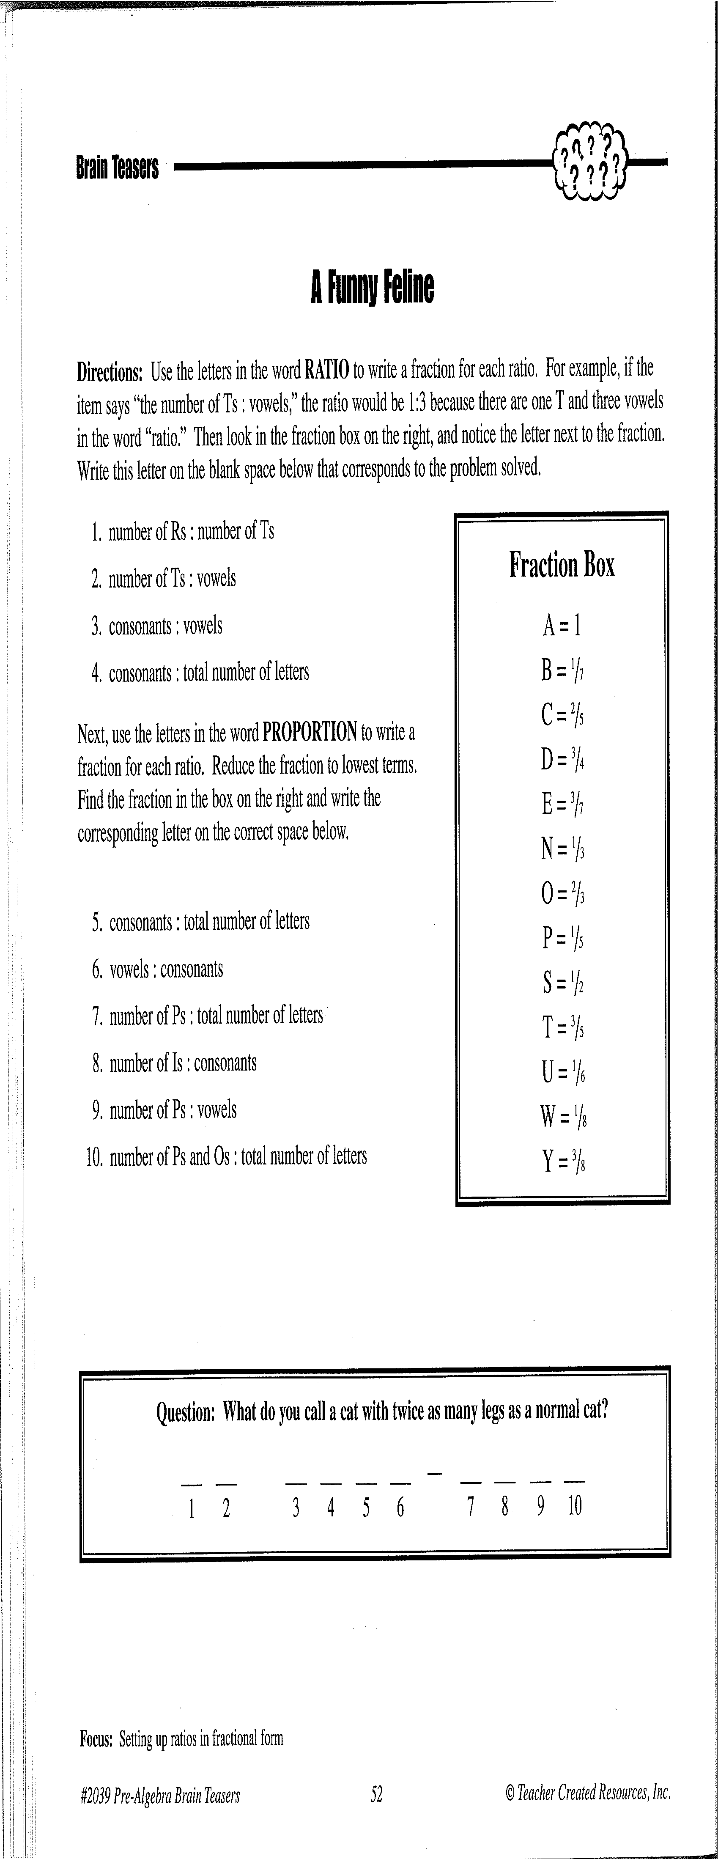

**Activity 2: (Fill-in all the blanks!)**

1:1=1

1:3=1/3



N

A

