**Name:___________________________________**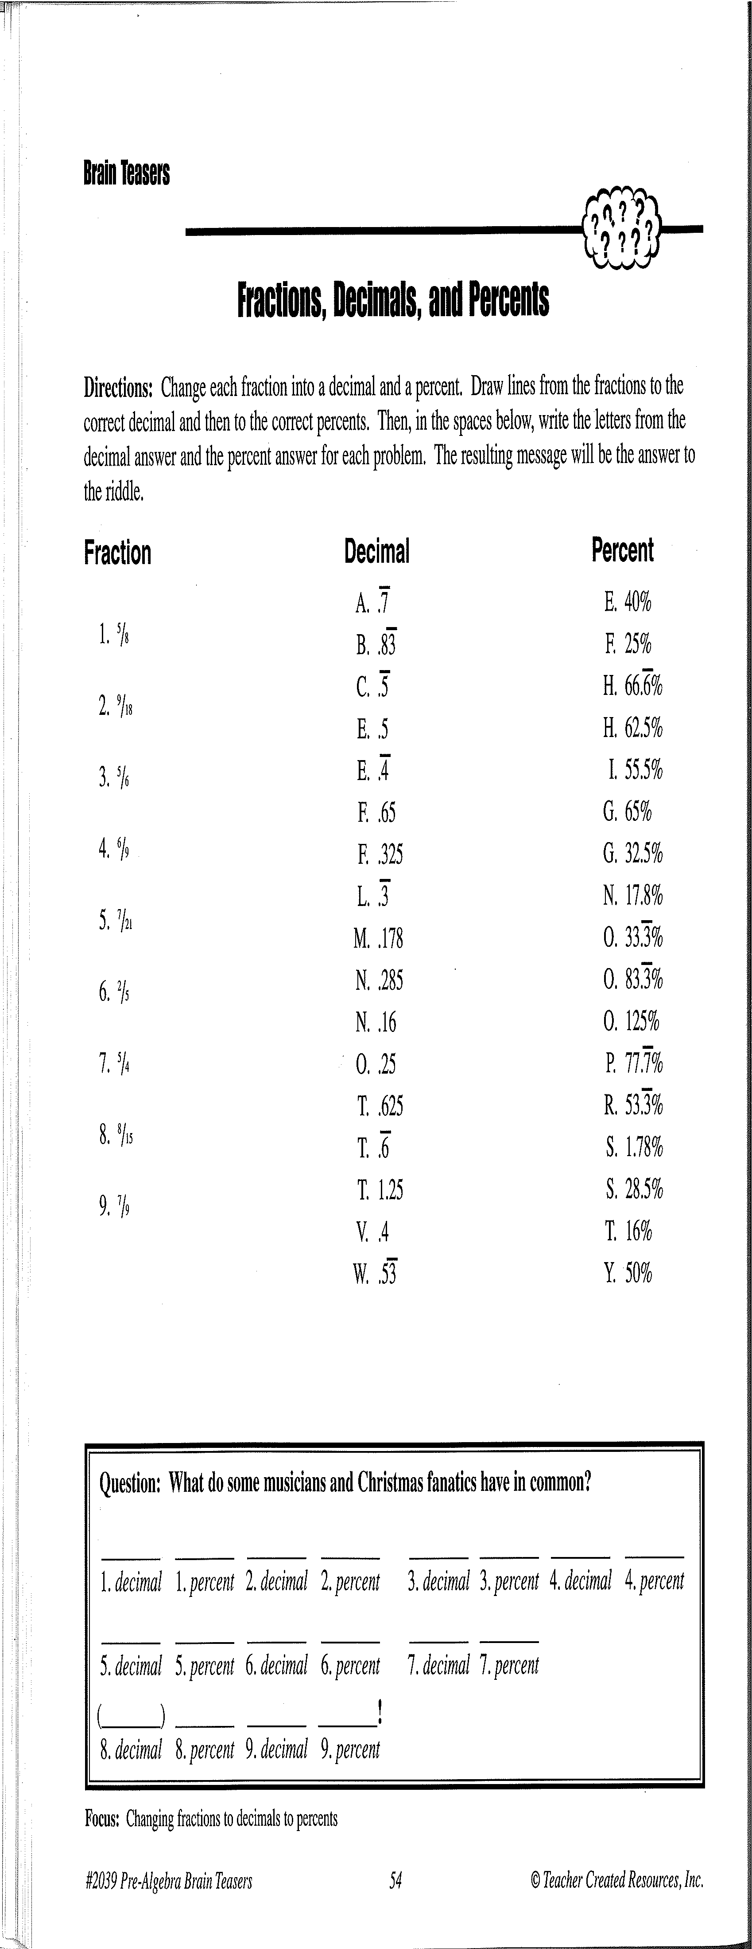

**Activity 3:**

**(Draw all the lines, and fill-in all the blanks!)**



H

T