**Name:__________________________________**

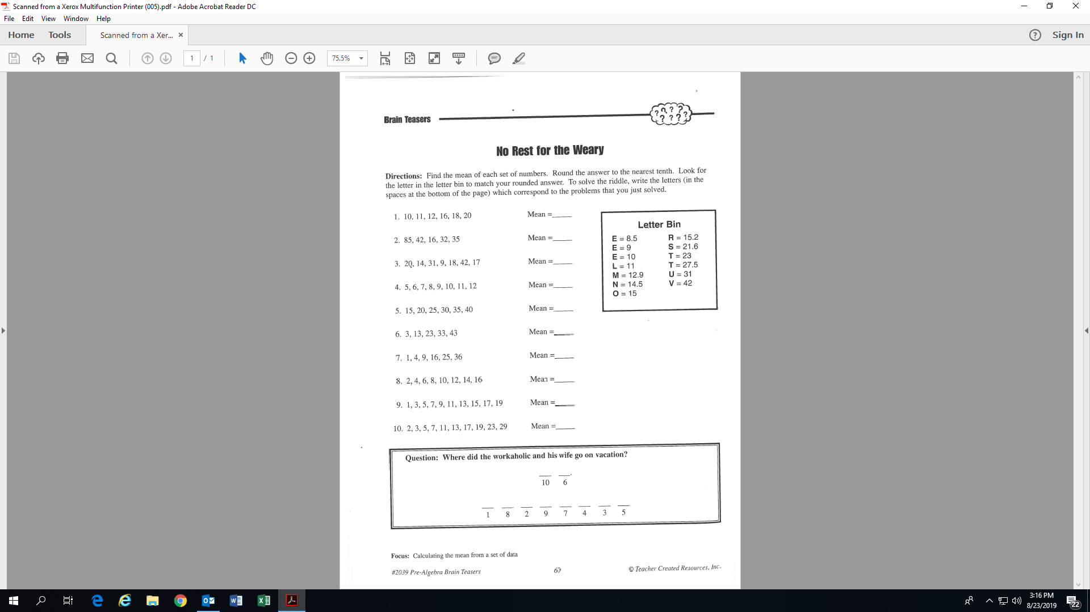

N

**Activity 4: (Fill-in all the blanks!)**

14.5

**Mean is just another word for average.**