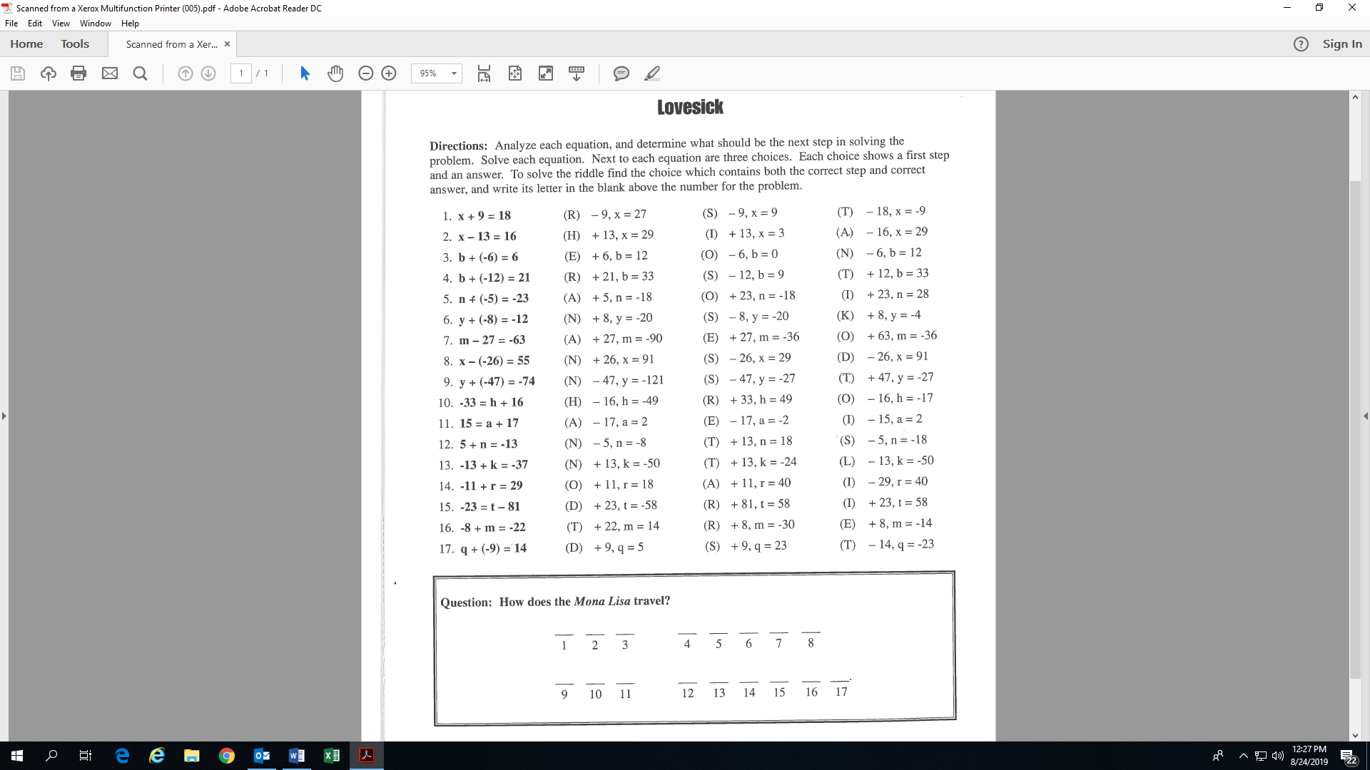**Name:________________________________**

**Activity 5: (Fill-in all the blanks and ovals!)**

S