**Name:________________________________**

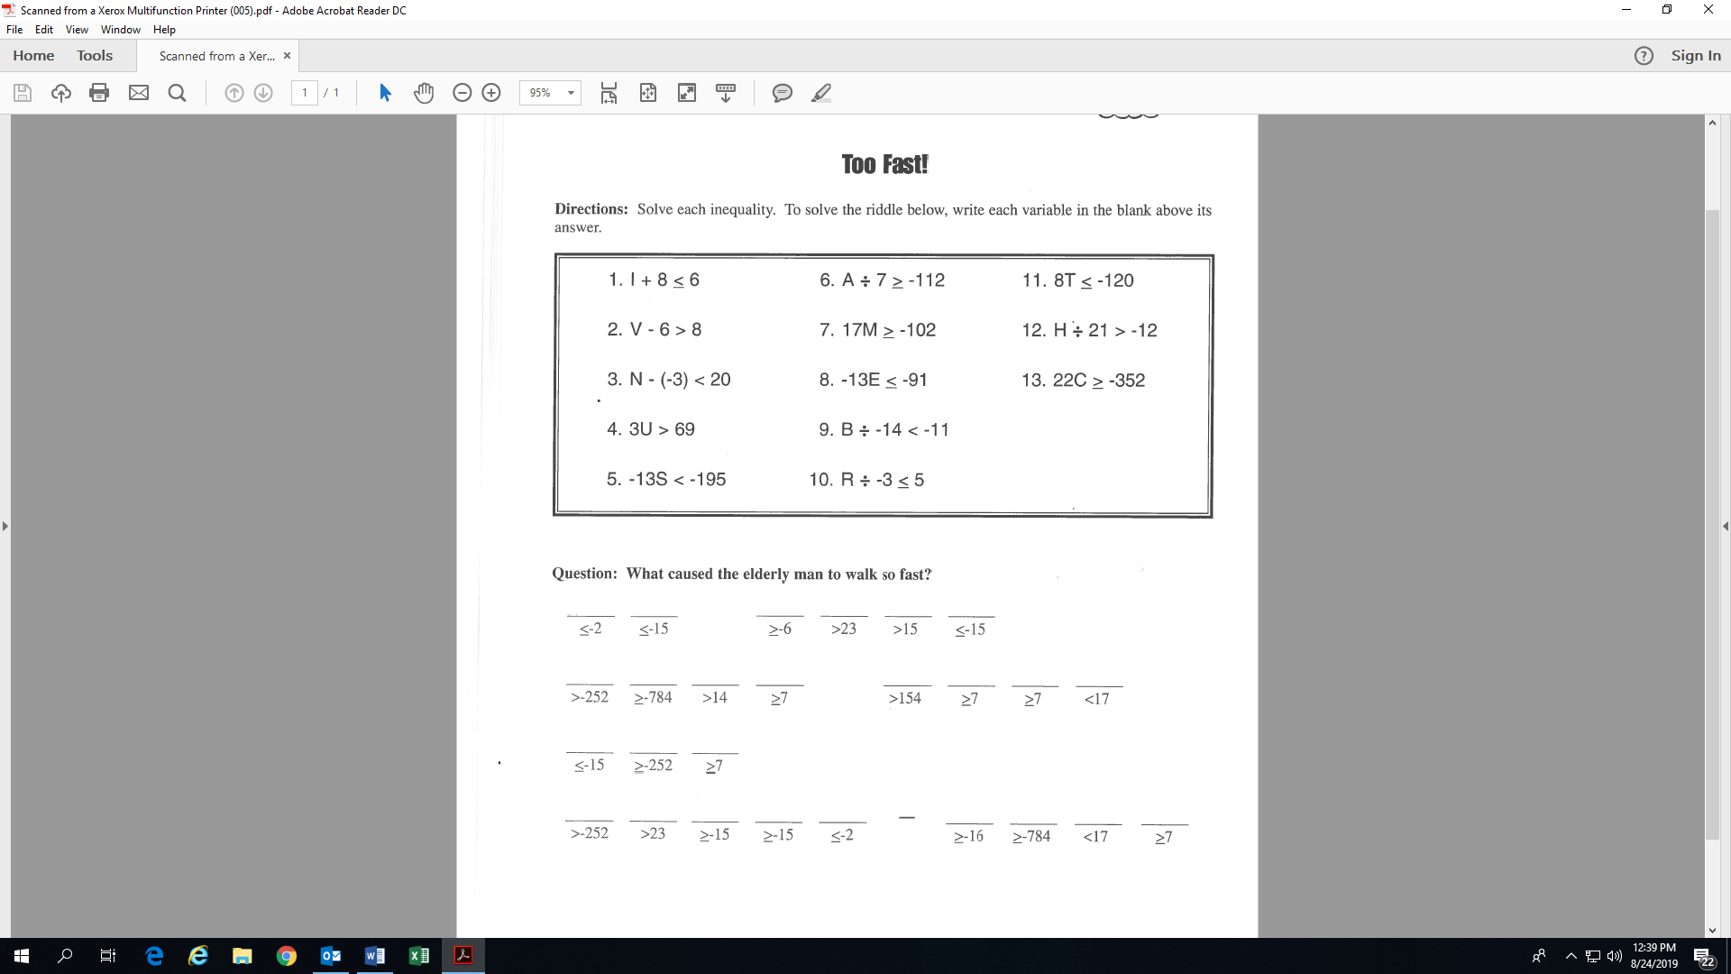

I

(I <= -2)

**Activity 6: (Fill-in all the blanks and solutions!)**

I

(T <=

(A >=

(H >

(M >=

(V >

(C >=

(E >=

(N <

(B >

(U >

(R >=

(S >