**Name:_________________________________**

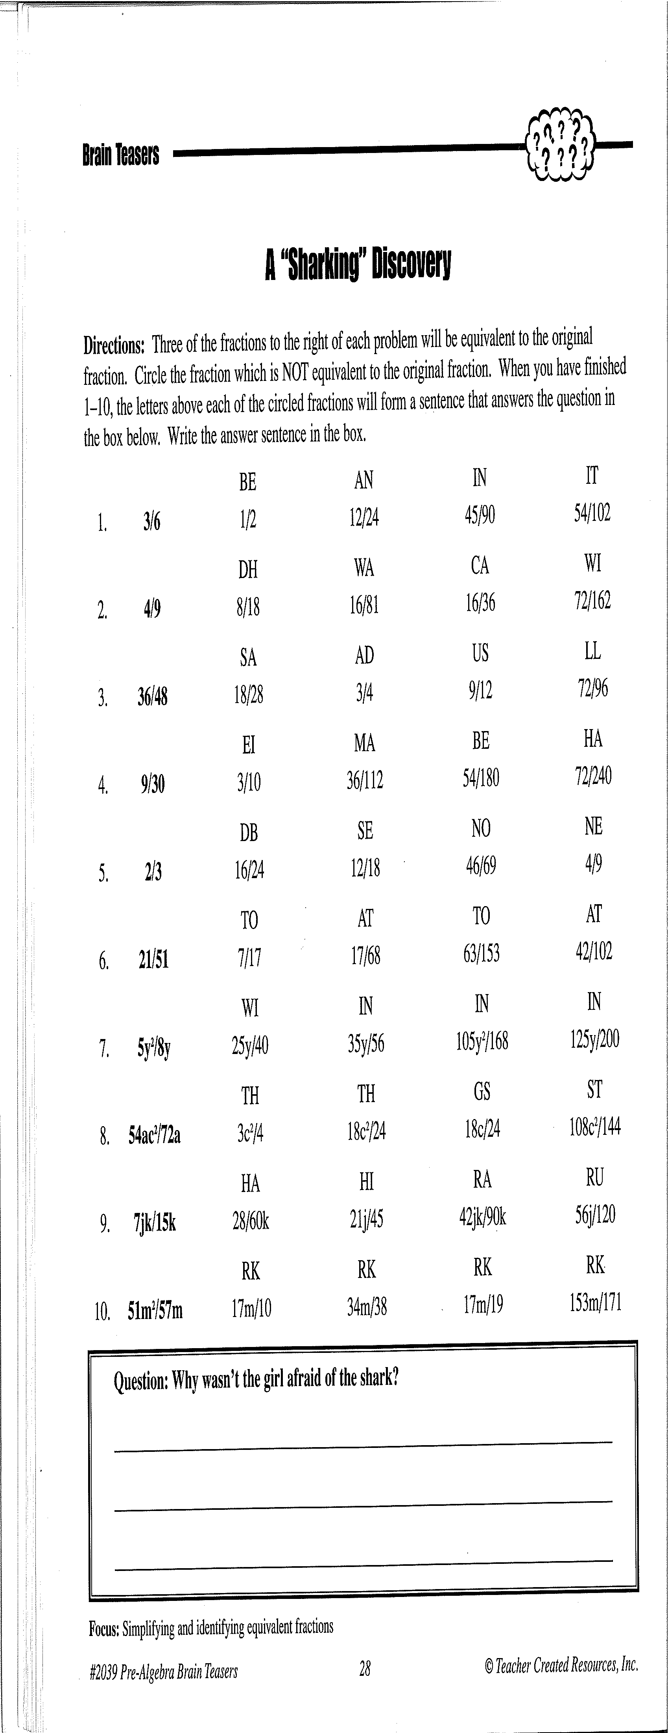

IT

**Activity 7: (Circle the appropriate fractions, and answer the question.)**