**Name:_________________________________**

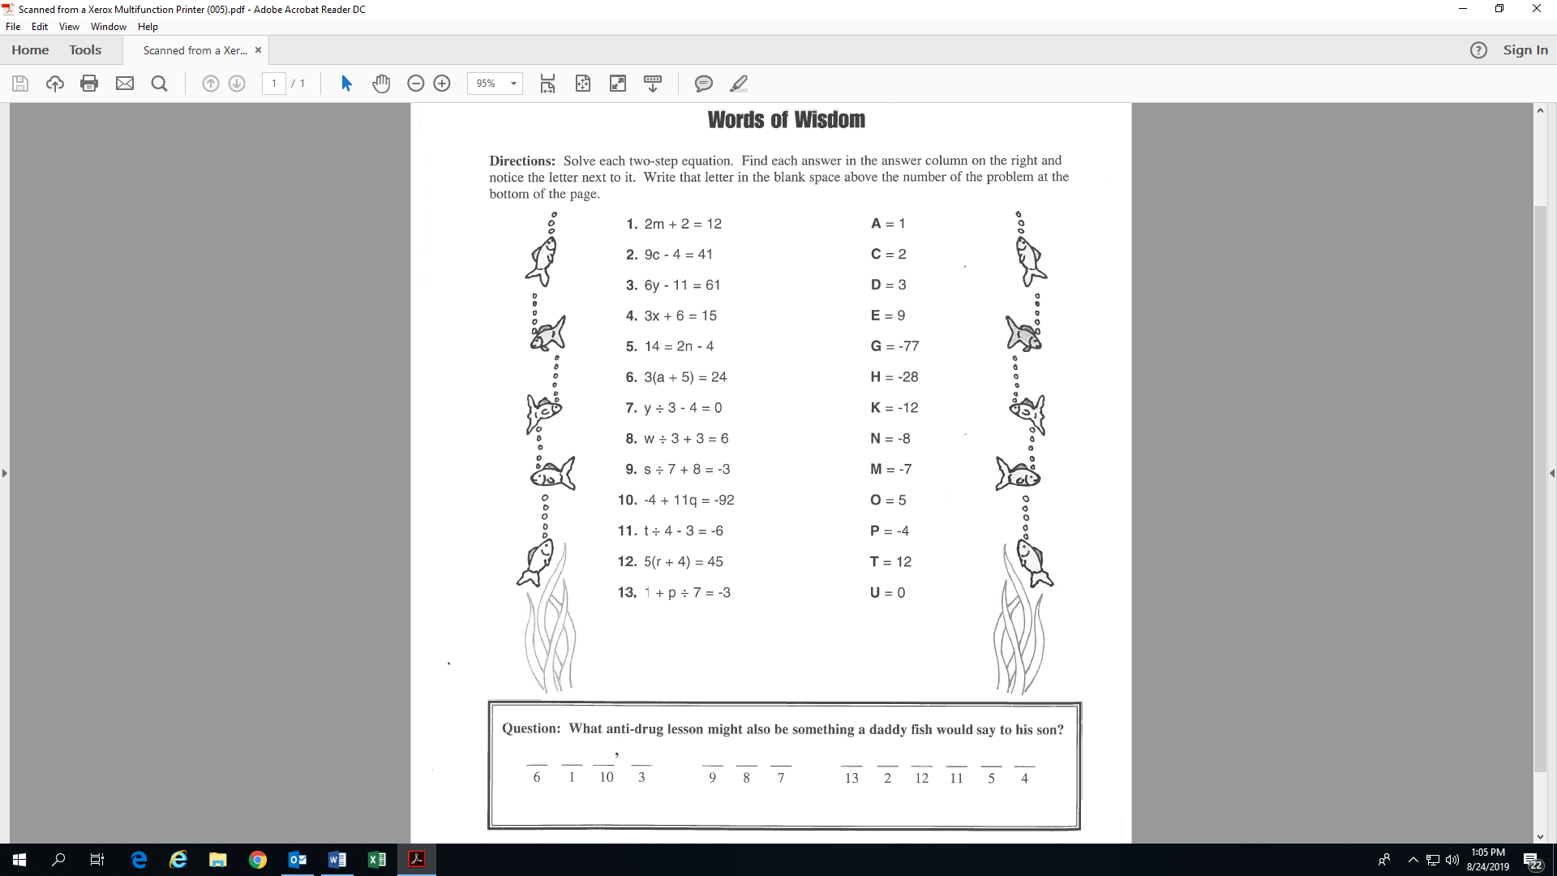

(r =

(w =

(m = 5)

(a =

(c =

(y =

(y =

**Activity 8: (Fill-in all the blanks and solutions!)**

(t =

O

(q =

(n =

(s =

(x =

‘

(p =