**Name:_________________________________**

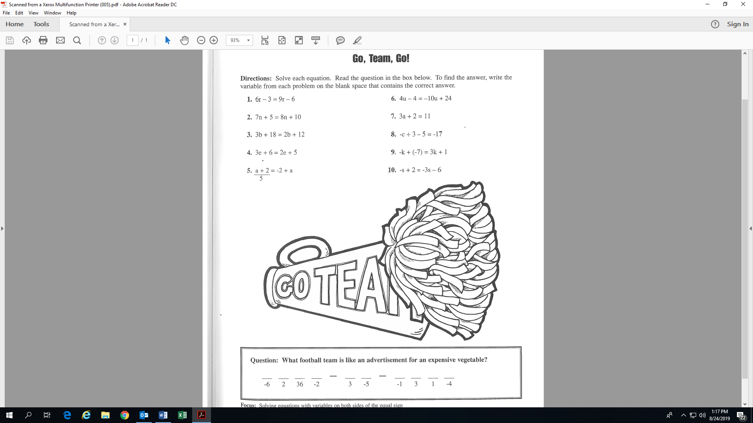

r

(s =

(e =

(b =

(a =

(r = 1)

**Activity 9: (Fill-in all the blanks and solutions!)**

(n =

(k =

(a =

(u =

(c =