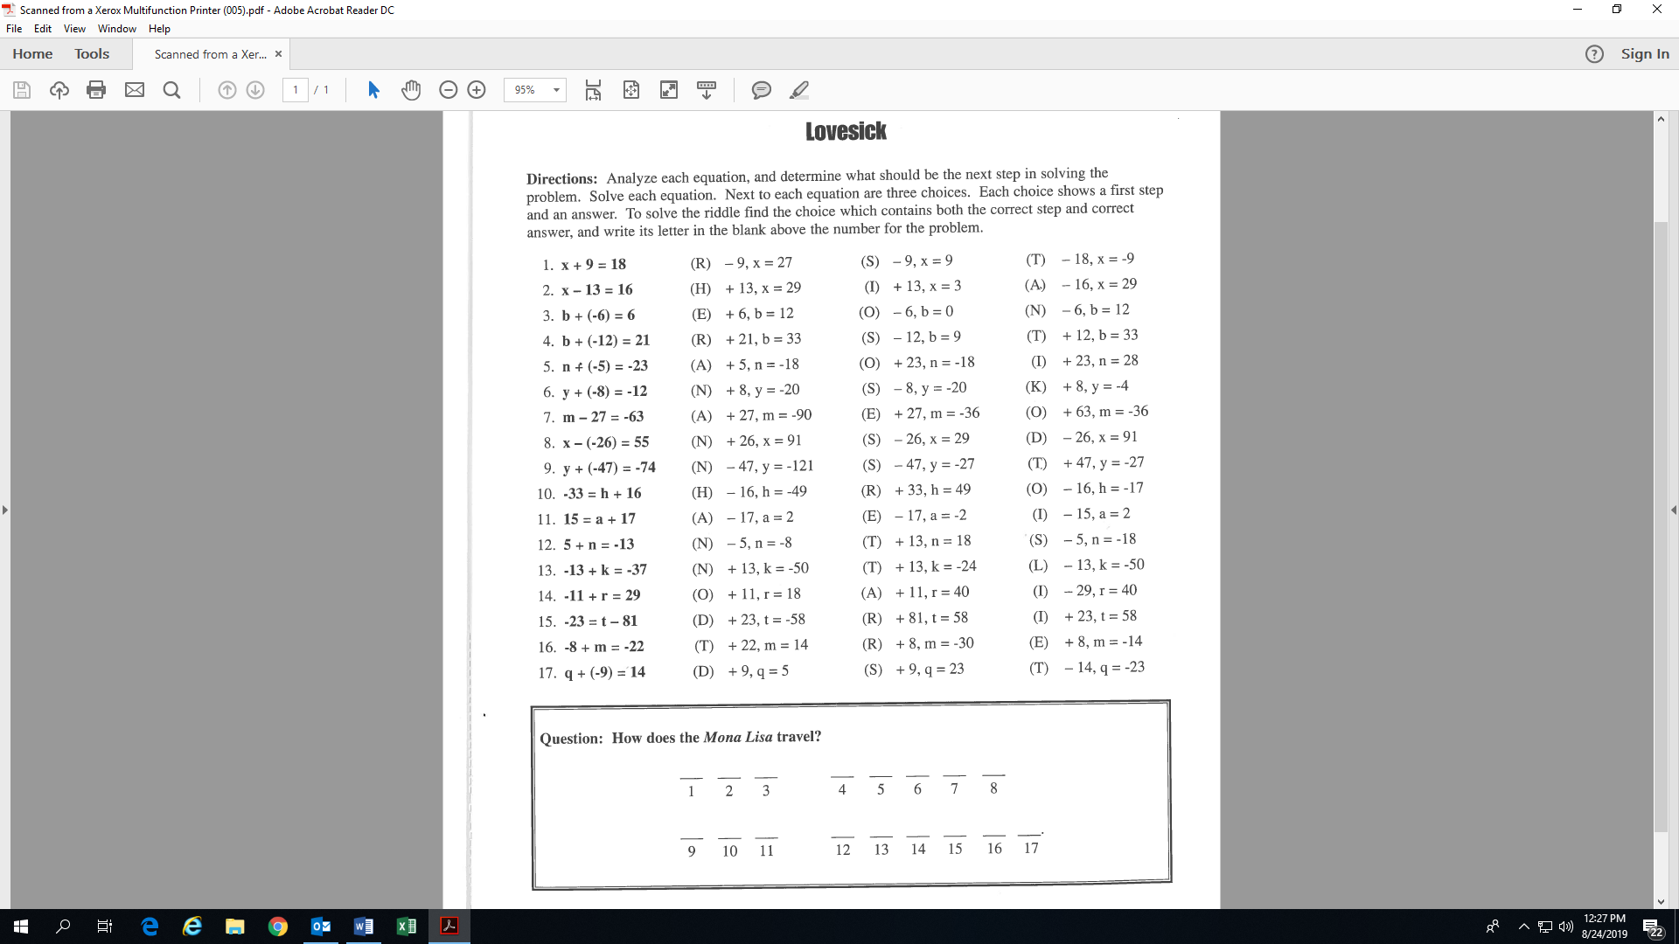
Name:________________________________
Activity 5: (Fill-in all the blanks and check marks!)

S



