Name:_________________________________
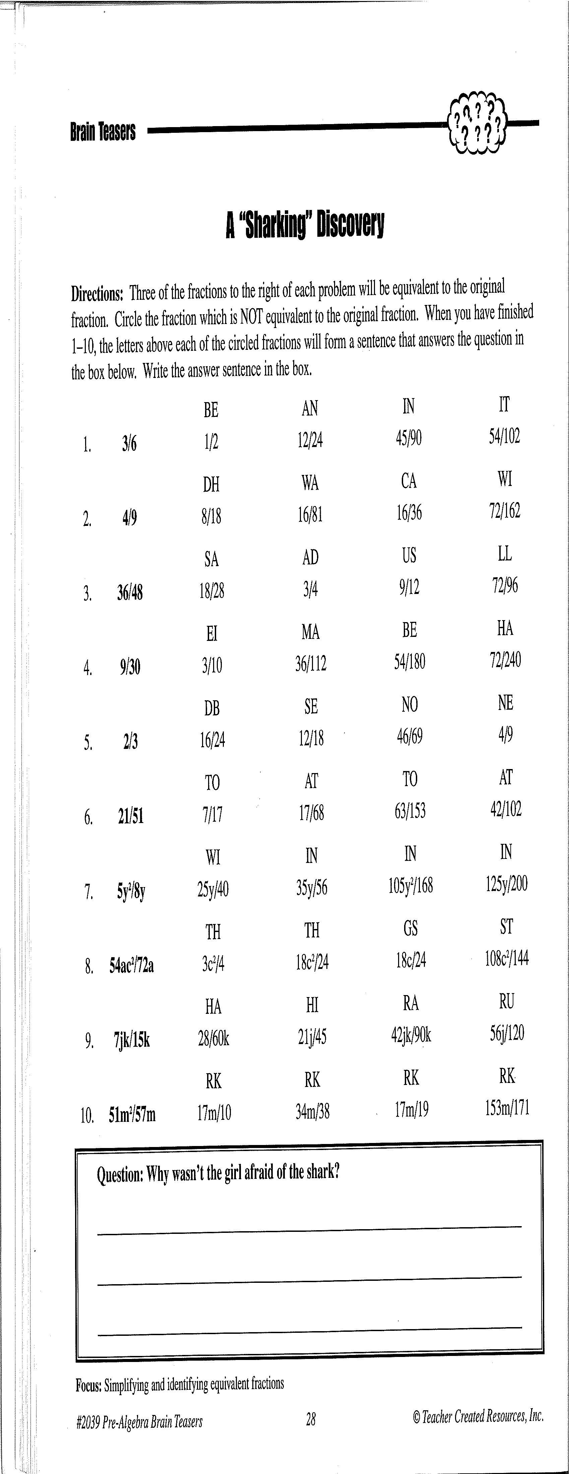
IT

Activity 7: (Check the appropriate fractions, and answer the question.)



